**Getting Started**

This login menu is shown below. Input your user ID and password before accessing the main page. If invalid user ID or password were inputted, an error message is prompted and allow user to re-try.

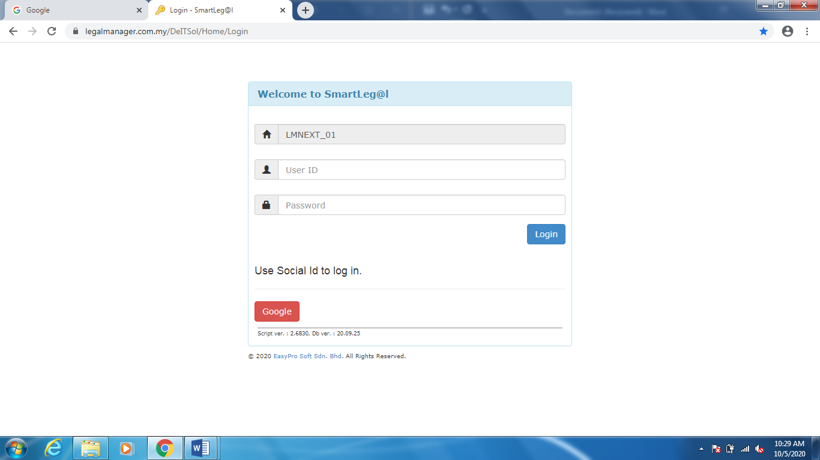

Figure: Login Screen

After logging in, SmartLeg@l main screen will display as figure below.

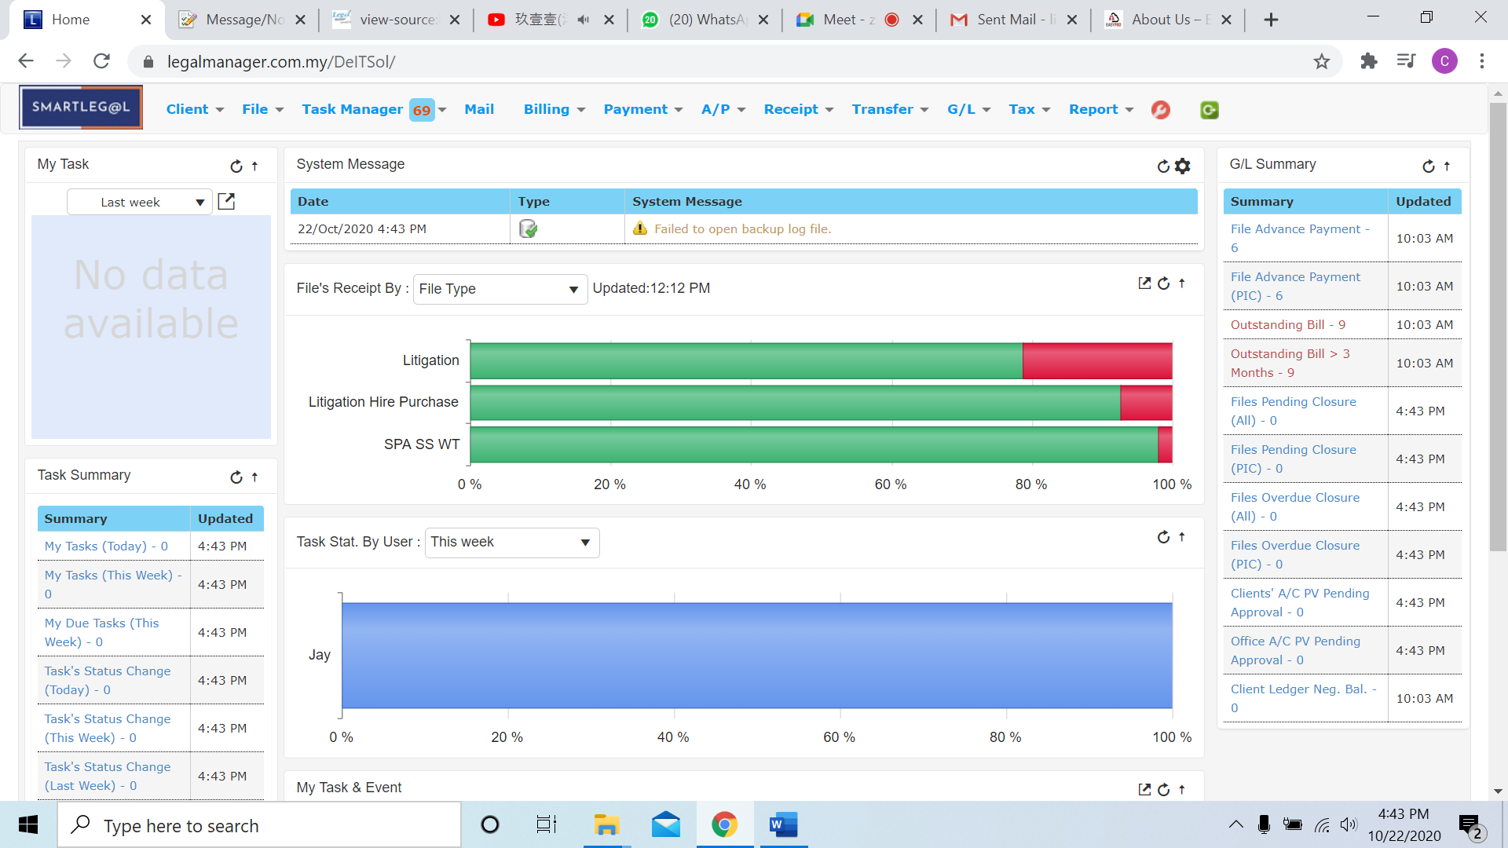

* In addition, you can customize your SmartLeg@l main screen by clicking the settings icon  at the position circle in figure below



* When you click to the settings it will pop-up a ‘User Widget Settings’ as figure shown

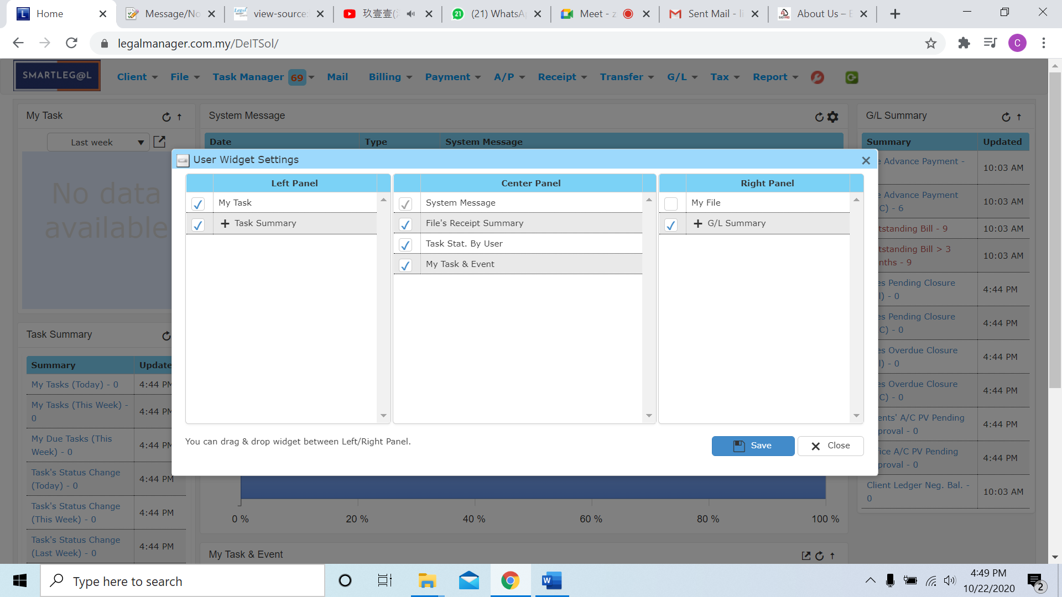

* Those ticked will be display in SmartLeg@l main screen, you can choose to untick those activity you do not want to show in the main screen. (e.g.: I unticked to File’s Receipt Summary inside the Center Panel)

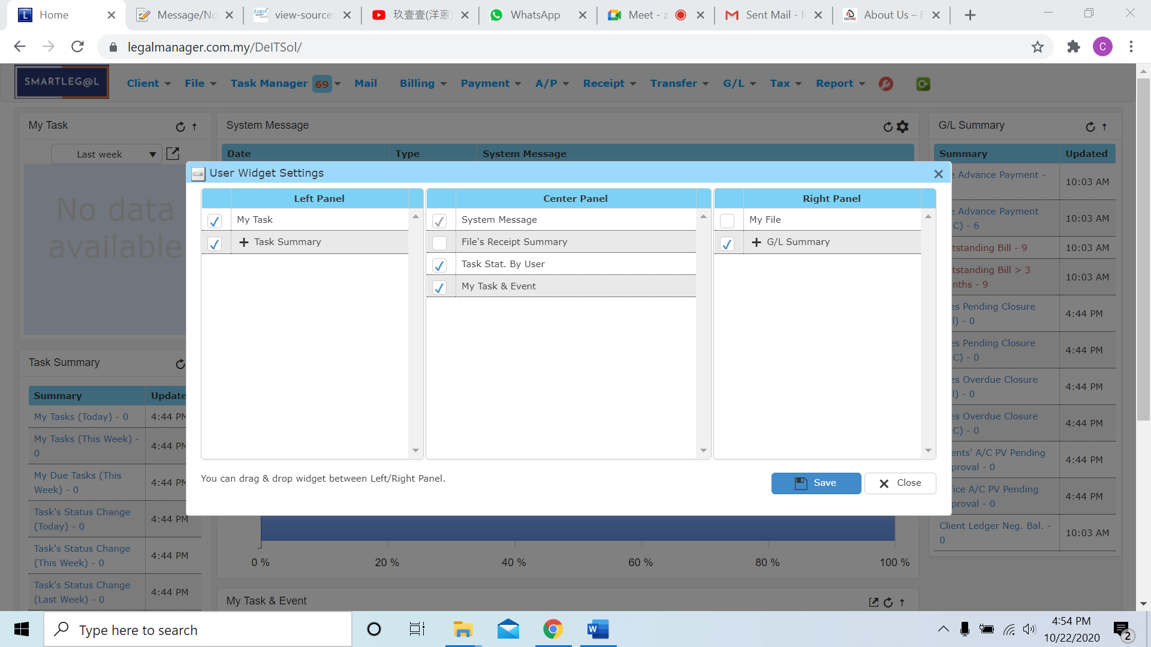

* When I click to ‘Save’ the main screen will changed instantly

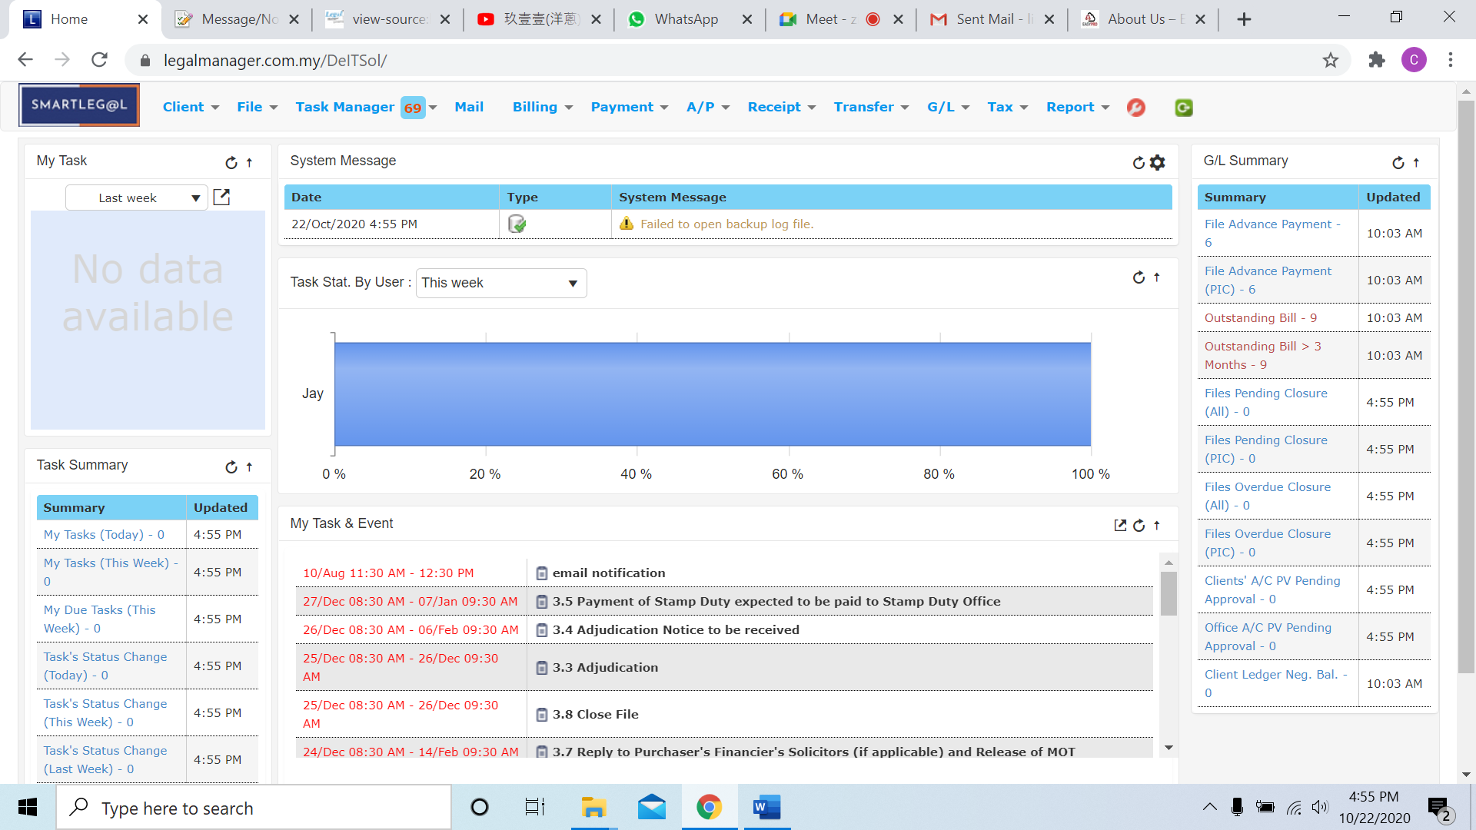

* The operate method to show or hide others activity is as well as the example to tick or untick in the settings

**My Task**

This **My Task** is the number and percentage of all your tasks. Green color in the pie chart represent completed task and red color represent as overdue task. You can filter those tasks by timeline.

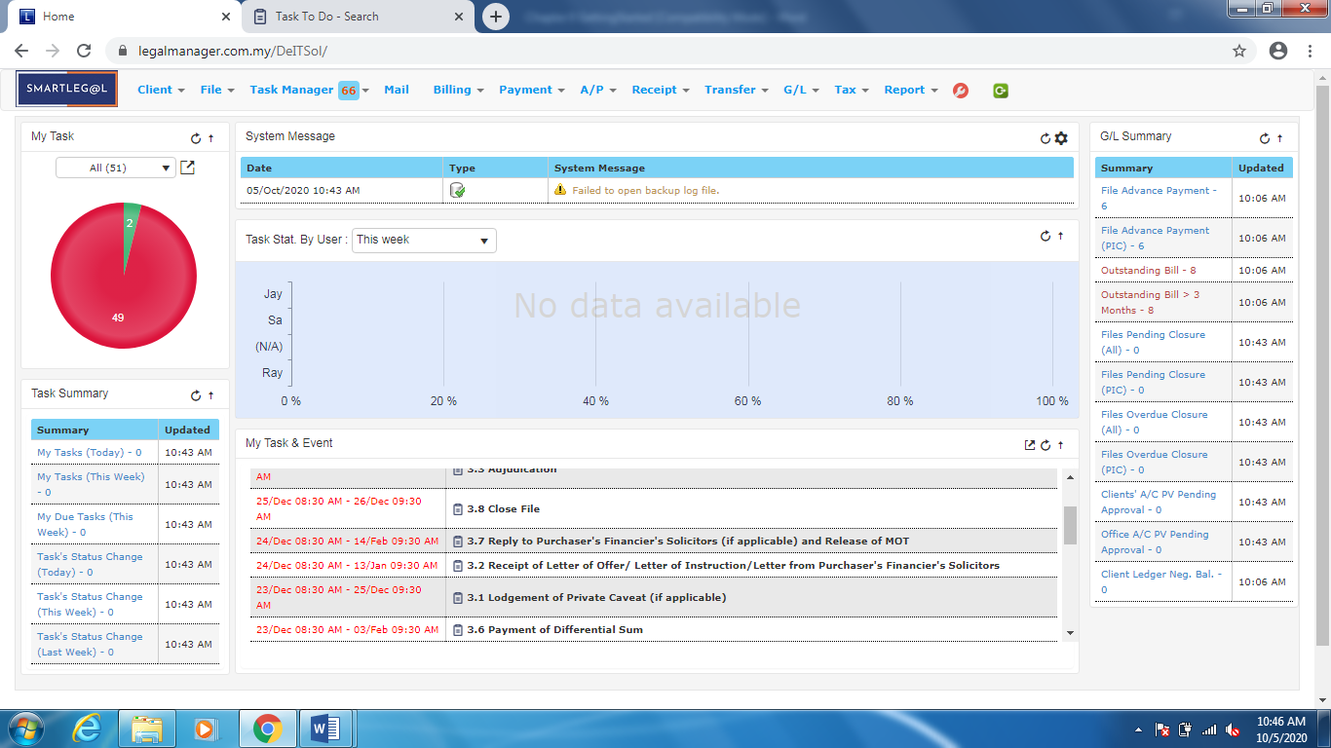

Figure: My Task

**Task Summary**

This **Task Summary** provides a preview of your to do list. You can see a summary of your tasks, due tasks and task’s status.

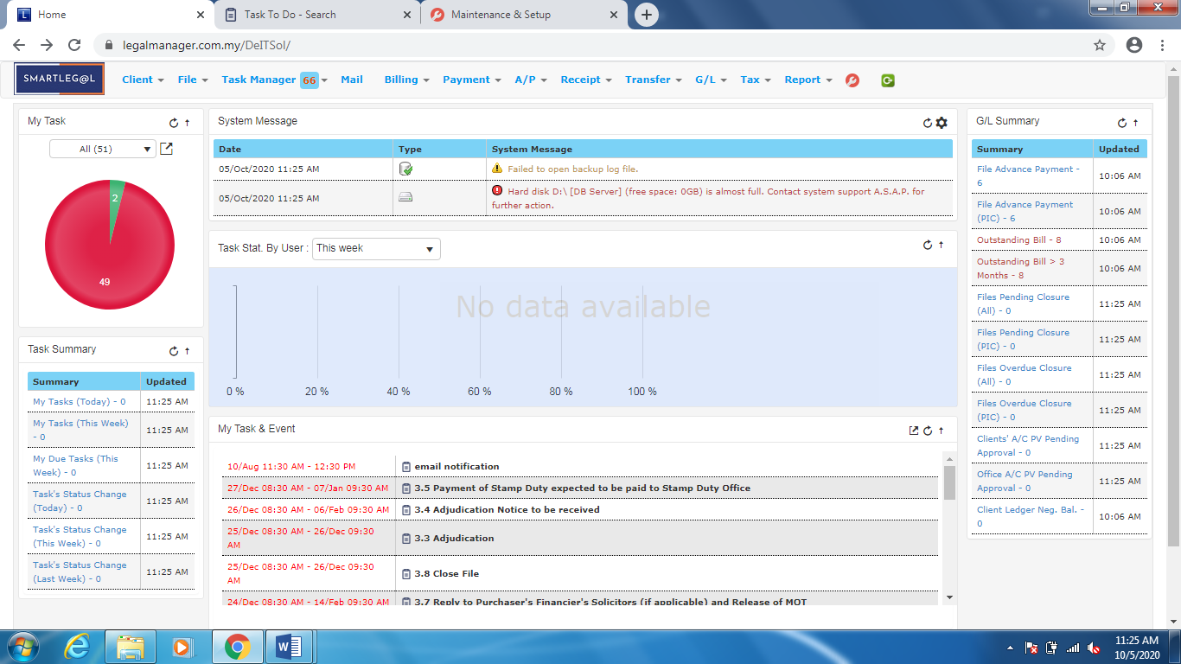

Figure: Task Summary

**System Message**

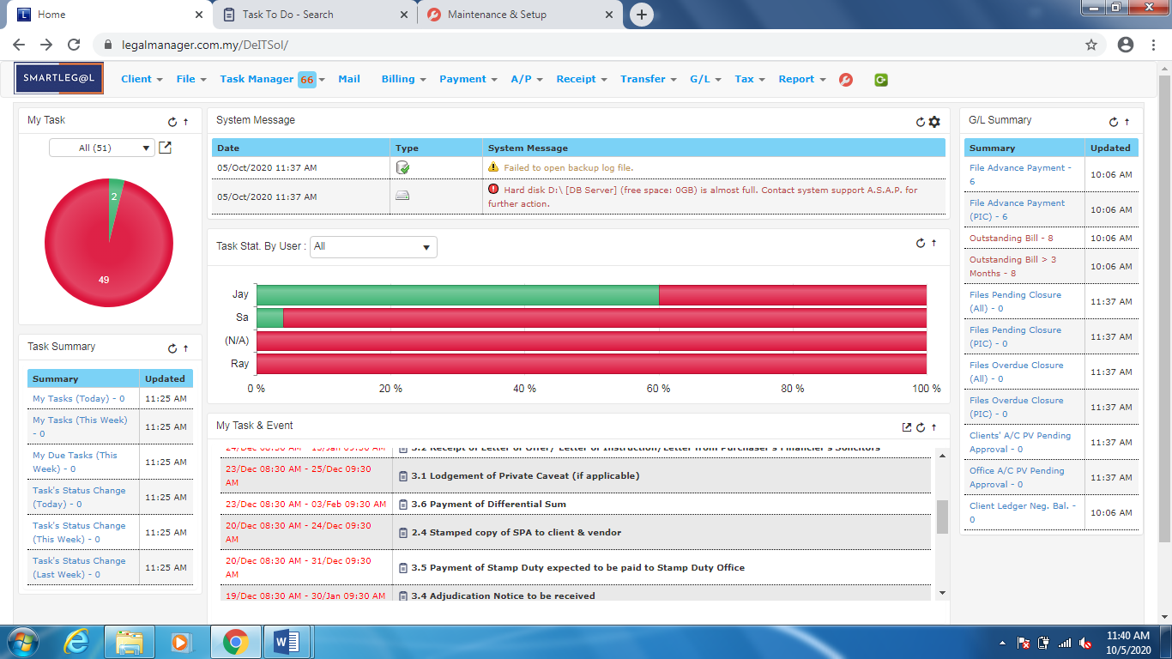

Figure: System Message

**Task Status by User**

This **Task Status by User** is used to view the processes about those tasks by user. It can also filter by timeline.

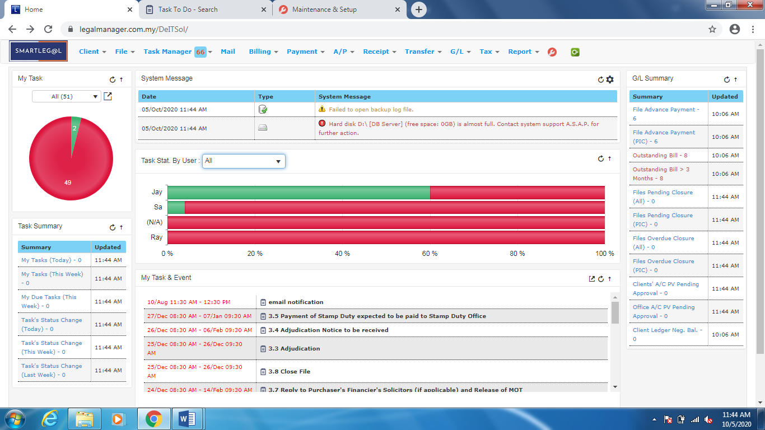

Figure: Task Status by User

**My Task & Event**

* This is a summarize tab for user to view task and event

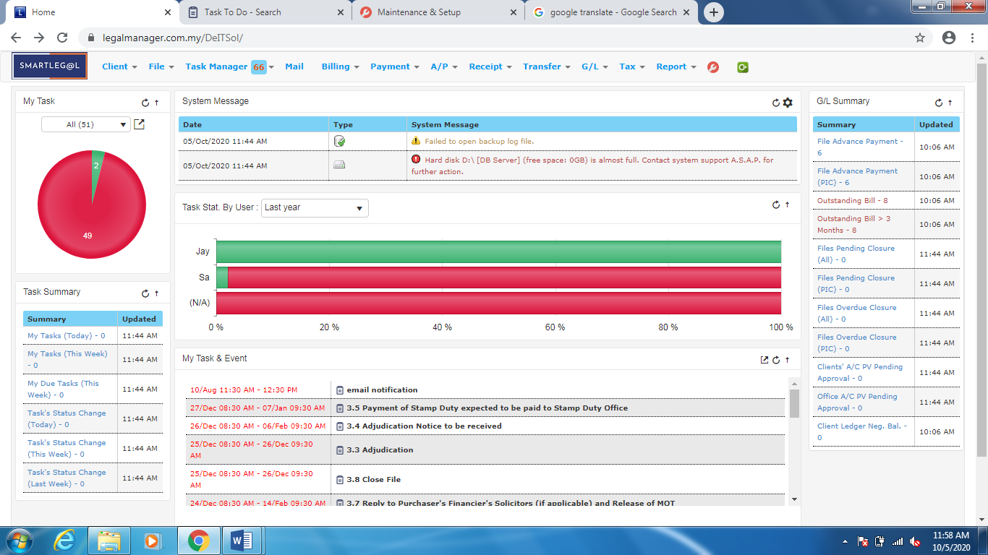

Figure: My Tasks & Event

**G/L Summary**

* G/L Summary on of the priority function is the system for user to have a look

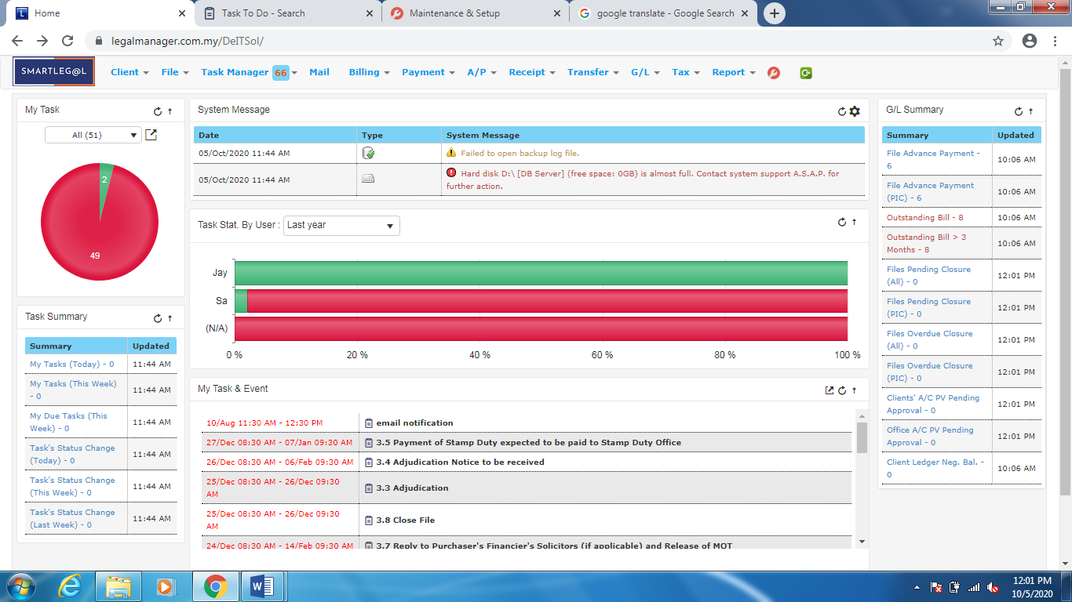

Figure: G/L Summary